Beyond Code Coverage: Functionality Testing With Playwright

Intro (3mins)
- This past year we’ve seen the amount of code being created by developers increase significantly. At GitHub last year we saw

  - Slide: 43.2M pull requests merged each month (+23% YoY) and nearly 1B commits pushed in 2025, the most active year in GitHub’s history.

- Many developers are starting to use AI to help them in their work. And though not all of the growth can be attributed to it, our data shows that a significant and growing number of PRs on GitHub are being co-authored and reviewed by AI Agents.

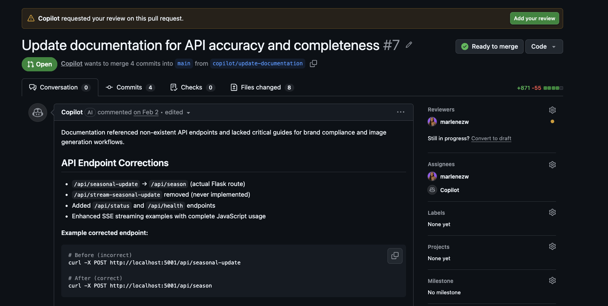

- I think for many of us our first instinct is to assume that this means that more PRs means AI is making developers more productive. But is that assumption correct?

  - Slide: ‘Does AI Make Developers More Productive?’

- One of the best studies I’ve seen so far on this topic was in another talk at AI Engineer by Igor at Standford, who researched 120k developers to try and understand the ROI of AI in software engineering.
- The main takeaways from their research is that clean code amplifies AI gains. While unchecked AI amplifies entropy so teams spend more time reworking and refactoring code! So even if developers were creating more PRs their research showed that if the cleanliness of the codebase wasn’t maintained those PRs often came with worse code quality and higher amounts of work re-writing the code for devs.

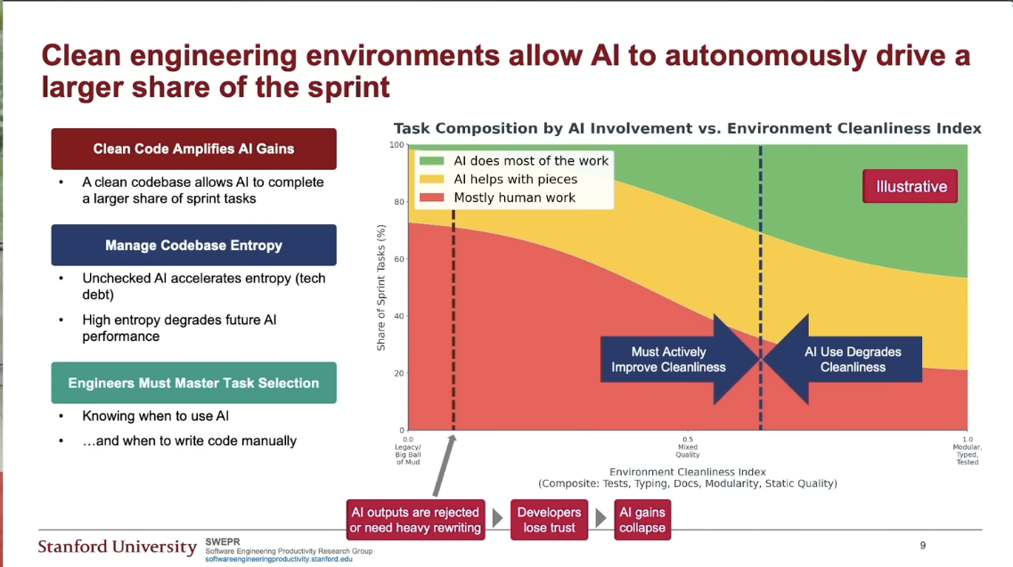

- So what should developers working with AI agents do to maximise the cleanliness of their environments and by extension the gains they can get from AI. Drawing from the study given by Igor's team some important things developers need to prioritise are test coverage, type coverage, documentation, modularity and static code quality.

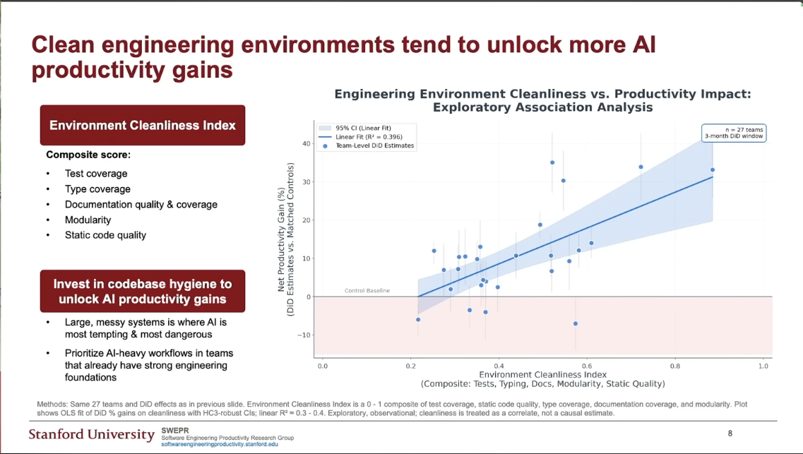

TDD and Agentic Coding (5mins)
- In software one of the most popular approaches that focuses on maintaining high code quality is Test Driven Development (TDD)

- Slide: Test Driven Development (TDD)

- For developers using TDD with coding agents we’ll focus on Red/Green TDD which includes the following steps.

- RED: Write a small test that doesn’t work, and perhaps doesn’t even compile at first
- GREEN: Make the test work quickly, committing whatever sins necessary in the process
- REFACTOR: Eliminate all the duplication created in merely getting the test to work

In the first 2 steps the goal is to make the code run. Quickly getting the bar to go to green dominates everything else. This shift in aesthetics is hard for some experienced software engineers

The Refactoring step is when we produce clean code.
It's when you remove the duplication [Beck]. It's when you sanitize the code smells [Fowler]. It's when you apply patterns [Kerievsky]
- TDD has historically not been liked by some developers and when I was doing some research I watched this excellent talk by Ian where he talks about how when writing tests in TDD many developers focus on testing code coverage which isn’t correct.

- Instead developers need to avoid testing implementation details and test behaviours. This is one of the reasons other approaches like Behaviour Driven Development or Spec Driven Development were created to help
  - ‘Avoid testing implementation details, test behaviours’
- Another way he phrased this is that you should test the API and not the underlying classes, only the exported modules.
  - ‘’

- I think this idea goes along really well with coding agents that we want to use to generate tests because they can sometimes generate self affirming tests that don’t actually do what we want them to. So Our primary focus should be to test the Functionality of our code and not just code coverage.

What is Playwright and How to use it (5mins)

- For the rest of this talk I’ll focus on how we can use PlayWright for functionality testing
  - ‘PlayWright’
- What is PlayWright?
  - Open Source Testing Library
    - Automates end-to-end testing
    - Simulates user interactions
    - Web browser based only
- What does running a test with Playwright look like?
  - Example code
- Ways to give your agent the ability to use Playwright today:
  - PlayWright Browser Automation MCP server
  - PlayWright Agents

- Playwright MCP server
  - Natural Language to Test generation
  - Browser automation
  - Screenshot testing
  - Manual test fixing required

- PlayWright Agents:
- Three Specialized Agents
    - Planner (creates test, plans)
      - Understands your app structure
      - Uses seed files and utilities
      - Respects existing code patterns
      - Foundation for good tests
    - Generator (writes tests based on plans)
      - One test per file (recommended)
      - Verifies elements before writing
      - Uses test logs to prevent hallucination
      - Runs multiple times for accuracy
    - Healer (fixes broken tests)
      - Runs tests in debug mode
      - Read console errors
      - Checks API responses
      - Adds ‘FIXME’ for app bugs

- Getting Started:
  - ‘Npx playwright init-agents –loop=vscode’
  - This command will autogenerate:
    - Agents folder
    - VS Code MCP configuration
    - Seed spec file

- (in vs code) What gets installed?

- Test MCP Server
  - Agents dedicated testing MCP server
  - Different from browser automation MCP
  - Special tools for testing:
    - Debug mode
    - Log verification
    - Test-specific operations

- Best Practices:
  - Use headless mode for multitasking
  - Enable Auto Approve for efficiency
  - Commit before healing
  - Generate tests section by section

- What does the Red/Green TDD loop look like when using our agents
  - Use the playwright agents for step 1 and 2, particularly taking time to review the proposed tests from the planner agent, but not worrying about implementation
  - Spend time refactoring your code so it looks good after a passing solution has been created

Some good CONTEXT for us to have is that over the past year or so we've seen this really massive shift in AI assisted coding. Initially when we started to see AI appear in our code it was through code completions. So an LLM would look at the last two or three lines of code you’d written and then make some auto complete like suggestions.

After this we started seeing the labs making models specifically for coding and when that happened LLMs began generating whole functions or even scripts for us, but you’d often have to copy and paste them into files. I also remember in this time LLMs were great at understanding errors so I’d sometimes copy an error from my terminal and paste it into ChatGPT. This was all really good but there was a lot of copying and pasting going on.

At some point last year, agentic coding happened. In VS Code for example we introduced something called 'agent mode' to Copilot, and using this mode turns Github copilot into an autonomous AI programmer. So when you ask a copilot for assistance it can plan, execute commands in the terminal, iterate on multi-step tasks and even debug its own code. A big difference here is that we actively give the LLM access to our full coding workspace and tools to be able to take action.

Coding Agents (slide 7)
Today there are many different Coding agents you can use. Whether you want to work in an IDE, CLI, the Web or build your own custom agents you can. Even though there are many coding agents available, most of them work the same way. A good way to understand how to get the most of coding agents is to know how they work.

(have a diagram listing out which agents are available in these places).

What is an AI Agent (slide 8)
To begin with, let's define what an AI Agent is. A widely accepted definition today is that
An AI Agent is an LLM that calls tools in a loop to achieve a goal.

The Agentic Loop (slide 9)

When it comes to coding agents they are often characterised by an Agentic Loop that looks like this. I actually took this image from a blogpost by Anthropic about how claude code works. For the rest of this talk we’ll use these three different parts of the agentic loop – gathering context, taking action with tools, and verifying results to see practically how to work with coding agents.

Gather context (slide 10)
When you give a coding agent a prompt for it to return the best results possible you need to give it as much high quality context as you can. There are a number of different ways for you to give an agent context. The most common way to provide an agent with context is to attach a relevant file to the chat. In copilot just by clicking on a file it should show up here ready for the agent to use. You can also click this context button and it will let you attach things like screenshots, Github issues and PRs. One way I like to use this is if I want an agent to generate a new feature but using a core API I use often, I’ll keep an example file with the code in it like this and tell the agent to use that as a starting point. I’ve found that agents sometimes use old APIs or overcomplicate code, so this helps to ensure that at least the core code I’m concerned about is based on best practices. I also like to say make the code as minimal and elegant as possible (have an example of agent with one style of code and have the agent update it based on best practices example file)

Another way to give an agent context is to create a file that helps it know how to behave. I mentioned earlier that you can build your own custom coding agents and to show an example of this here’s a file that I made earlier that contains the code needed to build an agent using the Github Copilot SDK. This is the code needed to create a new agent session, here we’re setting the LLM to be x and then this is the line of code we’re using to pass through the user prompt, in this case I’m just saying hello copilot. You’ll see the response here is a bit strange, it's greeting me and assuming I’m a running influencer and asking how it can help me get started. There’s nothing directly in our code that references this but earlier I created a copilot-instructions.md file that told the agent to act like an assistant helping a running influencer. The agent even in the sdk is going to see if an instructions file is provided and if it is will use that to define how it behaves. Different coding agents will use different files for this for example cursor has cursor rules files, claude has claude.md and openai has agents.md. Agents.md has actually become a bit of a standard and a second thing I’ll show you here is that I can create different agents.md files in an agents folder, and this will create custom agents in copilot that will each behave in specific ways. Lets say hi to our Python expert agent for example here.

Take Action using tools (slide 11)
Ok, great so we’ve seen a couple of ways we can help provide context to an agent. The next step in the agentic Loop is giving an agent tools so it can take action. Almost all coding agents these days come with standard planning, file reading and execution tools. For the sake of this talk lets see how we can give an agent access to more tools. One way to do this is through MCP. MCP is Model Context Protocol and it's an open protocol created by Anthropic. The primary way I see developers using MCP is to give their agents access to tools. In VS Code if you go to extensions and type in @mcp you’ll get a list of MCP Servers that have been vetted by Github that you can install and have your agent use. You can also create your own MCP servers with code. Once a server is installed I’ll click here on the tool icon and I can check the tools I want my agent to have access to. For example I can click…

Another way we can give our agent access to tools is through Agent Skills. To create a skill I need to… To test out that this skill works I’ll go ahead and open my terminal and we’ll test it out using the Github Copilot CLI

draw a quick diagram using excalidraw explaining mcp

To show a skill in action, lets walk through an scenario… imagine that I’m a developer working at a toy company called Tailspin Toys

To do this I’ll head over to my termninal and run the command to get GH Copilot started. (make sure on opus low) similar flow with verification

Verification (slide 12)
A final thing I want to talk about is the last part of that agentic Loop which is verification. Once an agent has taken all the actions it can, it might come back and ask you for more context to complete the task, or it might run the code and if it sees errors will start to debug and repeat the loop. For developers working on projects where they want to use Coding agents to add in new features or fix issues, its best practice to add instructions to your agent.md or copilot-instructions file to tell the agent to always add tests for any significant changes its made and then to verify tests pass before it comes back saying its done. I’ve noticed that although agents tend to be quite good at generating unit tests, these tests can be self affirming (find a study if possible.) One way we can go beyond code coverage tests and add an extra step to the verification process is by using Playwright

Best Practices (slide 13)

- Skills and agents.md combine the information from slide 10 and 11 of the original presentation to make one slide about context. Don’t keep the slide about prompting

Best Practices (slide 14 and 15, will both be about version control)
- Have slide 14 be about committing often and using different branches for different prototypes of the same feature
- Have slide 15 be about sending PRs, use the playwright example on slide 14 of the original but also add in the comment about not sending too many PRs on this slide
- Remove the current slide 16

Summary
Use the same general look of slide 17 but update it to be accurate with the changes

